Re: “写”（Xie）: Drawing as A Way of Writing

– On Chinese Brushwork Tradition
Hu Jun
PhD, Professor
Chair, Department of Art Education, School of Fine Arts,
Hangzhou Normal University
Researcher, Art Education Research Institute,
Hangzhou Normal University
Abstract:

Because of the expressiveness of the medium of brush in traditional Chinese art, the brush-work has become highly valued as an effective way of visual communication. Its aesthetics was concluded by a landscape artist Jing Hao in 9th century into “Six Essentials”(六要) of learning and evaluation in his masterpiece article Story of Learning Brushwork (《笔法记》). Brushwork is almost the synonym of Chinese traditional painting, which is basically monochrome “drawing”. In Chinese culture, the brushwork is valued not only for its aesthetic quality but also for its social function. The practice of the brushwork has a Chinese name: 写(Xie), literally “writing”, which hints the expression of hermit spirit challenging the spiritual hierarchy of the royalty. To create a dialogue between ancient Chinese tradition with art practices at AIAS 2012 Assembly, Sydney, might give us some inspiration on the discussion of the theme “Re: Imagine. Drawing in Dialogue - Narrative, Interpretation and Storytelling”.

Key words: Drawing; Chinese Painting; Six Essentials; Jing Hao
Chinese Water-and-Ink Painting, most typical of Chinese art, is basically drawing. “Painting” as the English translation to classify the Chinese art is not reasonable, if we define “painting” as the art practice to apply paints, because Chinese painting traditionally uses water-and-ink and almost avoids the use of color. Moreover, because the brush and the rice paper absorb water quickly and easily, the water effect of brushwork has so much variation of tones and textures that “drawing”, which is basically an art of lines, is not appropriate to name it, either.写(xie) , literally “Writing”, instead, has been used by Chinese artists to address the art activity. 写(xie) literally means “to write”, implying the power of dialogue, but according to semiotics, it has its original meaning as “to release” (certain kinds of feelings and sentiments). It is commonly used in 写山水(“to write” the landscape), 写花鸟(“to write” flower and birds), 写真(“to write” the portrait), 以形写神(“to write” the spirit with the form), etc..写(xie) implies the expressive rather than representative tradition of the Chinese art and the narrative power of the brush-work, which has been placed in the center of the stage of the Chinese art.
In this presentation, I would base my discussion on an essay written by a Chinese landscape painter Jing Hao in the 9th C. The essay is The Story of Learning Brush-Work. It has become a canon of Chinese water-and-ink painting although its length is as short as only 1800 characters. His discussion covered these topics:
- What is painting, or drawing?
- “Six essentials” of leaning and judging the painting, or drawing.
- What is “the real” in art?
- Four classes of aesthetic judgements.
- The existence of “invisible faults” in painting, or drawing.

Because of the limitation of time, I would concentrate only on two topics:
- What is painting, or drawing?
- “Six essentials” of leaning and evaluating painting, or drawing.

I would also relate the discussion to the 4 workshops to and symposium presentations that have just taken place in this assembly to build up a dialogue between Chinese traditional art and contemporary art practices.

Firstly, what is painting, or drawing?

When I told my students to prepare works to compete for AIAS Prix d’Honeur in accordance with the topic “Re: Imagine. Drawing in Dialogue - Narrative, Interpretation and Storytelling” of AIAS General Assembly 2012, they felt quite puzzled and asked me: “What does it mean by ‘drawing’?” I felt it hard to define, too. In Chinese language, there is no clear distinction between drawing and painting as in English language, for both “painting” and “drawing” in the western sense are grouped under the single character “画”（hua）in Chinese. We call oil painting as “画”（hua）, so do we call the linear drawing of a portrait and the perspective drawing of an architecture. It was astonishing to me that I realized for the first time that there is no equivalent Chinese character for “painting”, nor the exact equivalent for “drawing”! That was why it was hard for me to define “drawing” to my students. So, I defined drawing as “a monochrome two dimensional art composed mostly of lines and done with minimum media”, but my five students were obviously at lost with the definition, and actually redefined it each in his/her own way as expressed through the diversity of their works.
When we arrived at National Art School, Sydney to install our works for the exhibition, I felt quite released to see that we were not the only delegation that defined the definition in its special way. Therefore, I would like to introduce the Chinese concept of 画（hua）as defined by Jing Hao to see if we could contribute a little to our discussion on “drawing” with the legacy of Chinese water-and-ink tradition.
In the masterpiece essay Story of Learning Brush-work (《笔法记》), a young painter luckily met an old hermit who gave him a free one-day workshop on landscape painting. There were conflicting definitions between them about “what is 画 (hua), painting or drawing?”
The young artist said “画(hua), painting or drawing, is just a matter of beautifulness.” (画者，华也)The old hermit said he was wrong and defined 画(hua) as “the method to make a meaningful distinction”(画者，画也). This definition was puzzling even to modern Chinese artists, so I wrote and published an article to explain this definition according to the semiotics. At the same time, I retranslated Jing Hao’s article into English based on Lin Yutang’s (林语堂) English translation, titled “A Conversation on Method” published in 1967, because I thought Lin’s translation was not proper in most of the critical issues.
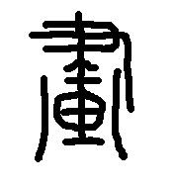=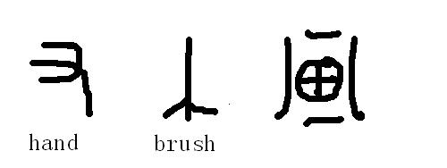
The traditional Chinese character of 画 is 畫, which vividly depicts a hand holding a brush and drawing something. What is the thing that is drawn? It is critically important to our understanding of the concept of 画(hua), that includes both painting and drawing.
画 (hua) starts with one stroke, the simplest Chinese character of one, 一（yi）. Then, two, 二(er) ; then, the four orientations,囗; finally, the Chinese character of field, 田（tian）, in the middle of four orientations. It vividly depicts the process of dividing land to make the field, to develop civilization out of wildness, to name things from the unnamed.
一
二
囗
田
画
So 画 (hua) is a human intervention of the nature to make a distinction with forms to produce cultural meaning. In this way画 (hua) starts from “drawing” a single line, 一, just as the language starts from naming, to convey meaning. This concept has been further explored by another important artist and theorist Shi Tao (石涛) in 17th C with the concept of “一画”(yi hua) , literally “the single stroke”, which I translated as “the Oneing” theory.
This idea of 画（hua）combined easily with the potential of the brush-work, which had been already developed to its mature stage through Chinese calligraphy in Jing Hao’s era, as we can see in the two masterpieces of the so called “Running Calligraphy”.
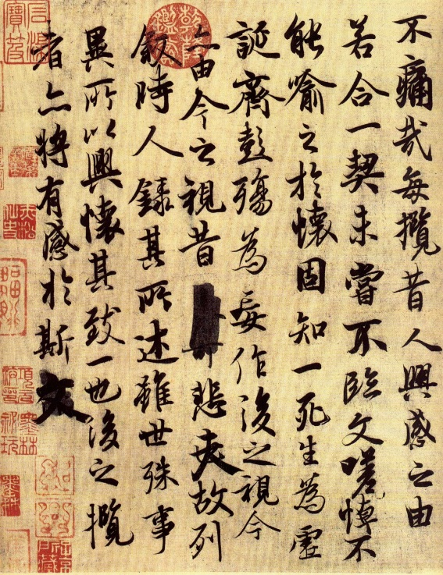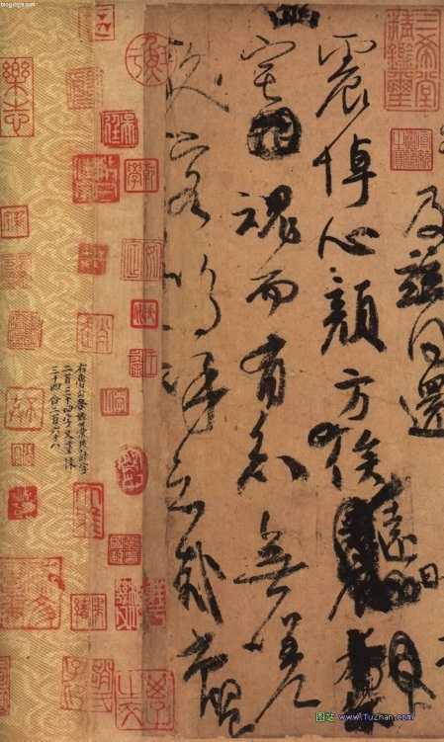
The left, “No.1 Masterpiece of Running Calligraphy” by Wang Xizhi (王羲之)in 4th C, and the right, “No.2 Masterpiece of Running Calligraphy” by Yan Zhengqing (颜真卿)in 8th C were among the most treasured Chinese art works; However, we can see from its draft appearance that they were not intentional artworks. The left was an essay written when the writer was completely drunk. He complained the shortness of human life span and expressed his love of occasional pleasure with friends or in the nature. The right was a very sad essay to be read aloud at his nephew’s tomb, who had been beheaded by rebellions. Without the artist’s intention to produce visual art works, but based on the full mastery of the brush, the narrative power of words was strengthened by the expressiveness of the brushwork to release meaning and feelings.
The aesthetics of Chinese calligraphy focuses on the spontaneous process of 写(xie) , writing, and its natural expressive power, rather than doing a beautiful piece of art that appeals to the eyes. In this way, writing, or写(xie), becomes a kind of drawing, or画(hua), an art practice without aesthetic intention. In fact, most untrained eyes don’t find the two masterpieces beautiful. The right one is often regarded as ugly if the viewers don’t know the great name of the calligrapher. This special aesthetics of calligraphy has been brought into Chinese water-and-ink painting. The activity of写(xie), writing, or improvisational and spontaneous expression of the brushwork, more than just drawing, has been valued much higher than the representation of the objects. Thus, the brushwork, with its origin in calligraphy, remains at the center of the stage but characters are replaced by images. That is why Jin Hao’s essay about the art learning is named “Story of Learning Brushwork”, as I translated the title 《笔法记》(BRUSH-WAY-RECORD, word by word) faithfully.
In the following part, I would explain Jing Hao’s definition of the “six essentials”, and see how they are relevant to our discussion of drawing. Jing Hao was a hermit, just as most of the great Chinese landscape artists are hermits or half-hermits. His Story of Learning Brushwork was a fiction about a hermit learning from another hermit, too. In this sense, Chinese landscape painting is part of the hermit tradition. Bearing that in mind, we may understand better the value of Jing Hao’s “Six Essentials” of learning and evaluating “画”(hua).

“Six Essentials” of leaning and evaluating画”(hua), painting or drawing.
The “Six Essentials” are 气(qi), 韵(yun),思(si), 景(jing), 笔(bi), 墨(mo), which have become the keywords in the discussion of Chinese art for over a thousand years. However, they are unlikely to be translated with perfect English equivalents. I tried at least to make partial success in the translation which I hope would bring us some inspiration to our insight into art, especially its education and evaluation.
- Energy Flow(气，qi).
Energy flow, or气(qi), should be as natural as wind, which is the semiotic origin of the character, as in its earliest way of writing.
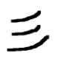
It is put as the first priority among the six essentials, which means that the process of art making should be learnt from nature, and be spontaneous. According to traditional Chinese philosophy, the form of our world is the interactivity between Ying and Yang, which was represented by water and ink in art. The simplicity of the material and the abiding by simple rules does not prevent the sophistication of the art process.
In Briony Barr’s workshop “Drawing on Complexity” that PVC tapes were applied to the floor, we can see how she instructed students to process like a flock of birds, or ants, or bees, based on simple rules, as she described it. She cooperates with scientists to learn the principles of the nature and imitates them in an artistic way with coloured tapes to develop a complex system without a leading planning ahead. The spontaneity of the process was comparable to Chinese art, as demonstrated in the above works of calligraphy and the sophistication of the result was just as impressive.

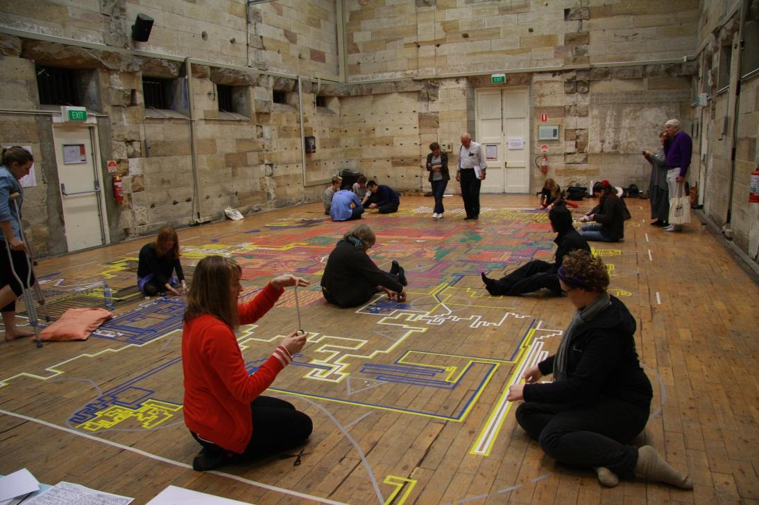
Briony Barr’s workshop “Drawing on Complexity”
- Suggestion of high morality through harmony (韵,Yun) is “to suggest the independence and unyielding character of a hermit that is not drab and common.” (隐迹立形，备仪不俗) It is a bit confusing to a Westerner unfamiliar with Chinese history, in which hermits played an important role in politics rather than in religion. Chinese hermits had nothing to do with Western morality that keeps social order. They were set up as moral examples just for the opposite reasons. Morality of a hermit is a defensive and oppositional stand to keep one’s independence against society. In a society that was lack of democracy, hermits, as well as intellectuals embodied with the hermit spirits, played partially the risky role of the opposition party. They tried to set up a spiritual union through the painting of “mountain-and-water” (山水), which was the hermits’ living environment. Politics in the veil of landscape is the real theme of Chinese landscape painting. However, this tradition of political involvement has almost been ignored by modern Chinese landscape painters, which has led to the degrading of the value of the art.
In the workshop of “the Big Picture”, Locust Jones instructed the students to make collectively a 20 metre long scroll drawing in response to political issues. Its outcome was quite abstract and expressionist, and as a result, the political ideas were much blurred. Why doing something political in this way, if a realistic art-work can represent the ideas better and clearer? According to the experience of Chinese art, art can work as “social networking”. There was the Chinese tradition of collective art making called 笔会(bi-hui), brush party, in which collective concern and sense of union was quickly formed during the art process. Chinese landscape painting, as developed by hermits with Taoist background, was often a visual confrontation against Confucianism as the ruling ideology, with its preference of abstraction against the royal preference of realistic representation. Therefore, sharing similar style of art was not a shame in Chinese art tradition and was often strengthened by exchanging works between artist friends, because Chinese art has the function of “social-networking”. In my later dialogue with Locust Jones, he said my comment on his job was interesting and found it inspiring, though he never thought it that way.
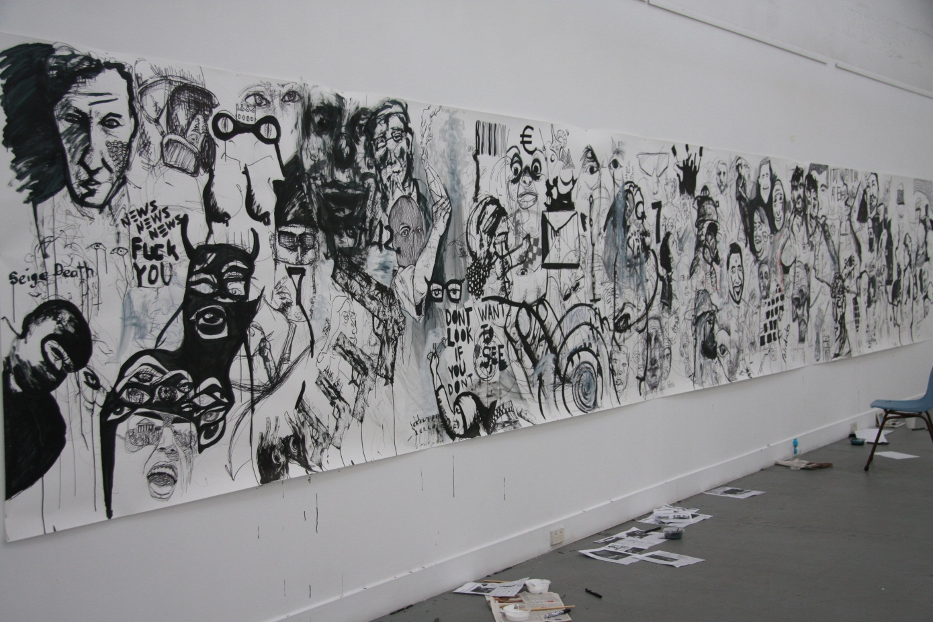
Locust Jones’ workshop “The Big Picture”
- Meditation (思, si) means “to catch the reality through abbreviation, and see forms from inside of yourself as body and mind working in one piece”( 删拔大要，凝想形物). I would like to respond to Tina Salama’s presentation “Situation as Medium”. In the presentation, she discussed on how the body functions in art making process, using Rafael Lozano-Hemmer’s widely exhibited Pulse Room (2006) as one of the examples.
“Viewers line up to have their pulses recorded by placing their hands on sensors, each pulse sequence is pushed around the room on a grid of light bulbs. The artwork is a room filled with the heartbeats of over a hundred viewers. In this way the viewer voluntarily completes the work with their desire to see their own heartbeat translated into a flashing light amongst other flashing lights.”(Tina Salama)
According to Chinese tradition of Taoism and Zen Buddhism, mind is not a perfect thinking tool without involving body in the conceptualizing process. According to semiotics of the character 思(si), which means thinking, is made up of two images, the brain upward and the heart downward. Both are human organs of thinking, and actually linked into one piece as believed by Ancient Chinese. So conceptualization is not just the work of the brain, but strongly bodily based as demonstrated by the practice of meditation of Taoist and Zen Buddhists. In meditation, one can feel his/her own circulation of blood and its rhythm, just as one can see his own pulse in the Pulse Room
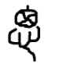
Another presentation “Mike Parr in conversation with Katie Dyer” demonstrated how meditation (思, si) works its way toward drawing. Mike Parr, as one of the most ground-breaking artists working in Australia today, was joined by NAS Gallery Manager & Curator, Katie Dyer in conversation about the nature of drawing within the context of his own practice. In Mike Parr’s works, as we learnt from his conversation with Katie Dyer, his art is strongly bodily based. He used to be a performance artist, and gained his understanding of art and expressed it through extreme physical experiences. His “body art” has its consistent expression in his “Self-Portrait” series, too, after he decided to concentrate on painting. As we see from Mike Parr’s video of performing a painting, his painting process easily reminds me of the art activity of a Chinese painter or calligrapher, leaving strokes of momentum from inside on canvas. The power of knowledge gained through the body gives life to the art works.
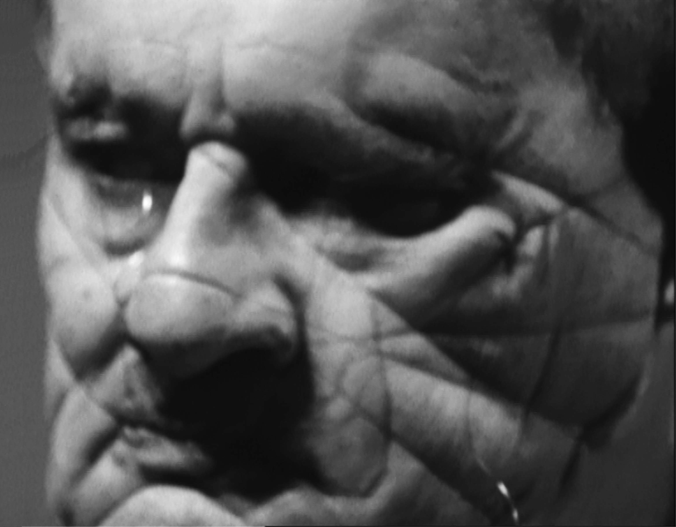
Mike Parr / Adam Geczy, The Mass Psychology of Fascism, Zip-a-dee-doo-dah, Zip-a-dee-ay, 2004, Mixed media video installation, 2004
Meditation (思, si) is a very important part of art learning, but can easily be ignored in today’s art education, because it has been regarded as irrational and mysticism. Besides we are depending increasingly on computers that are so powerful that need only a few clicks of fingers to create images. Why the whole body then. However, I am happy to see at this conference that the invention of Sandde 3D drawing software, as in the workshop taught by Leila Sujir and David Seitz, provides a possibility to connect digital art making process with human body function in space.
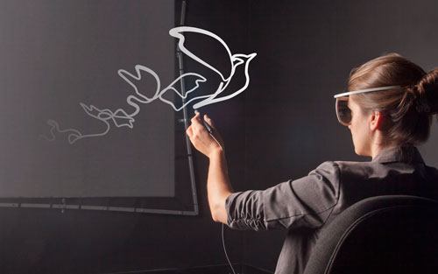
Drawing with Sandde system
- The Imaging (景, jing) means “to have regard for the cultural context and to create images that subtly represent reality (or the genuine)”( 制度时因，搜妙创真). According to semiotics, the character depicts an impressive building on high platform under the sun, which means something obvious.
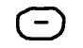
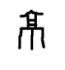
In the specific case of Chinese hermit landscape painters, it was to draw a picture of their hermit living environment of 山水(shan-sui), “mountain-and-water”, as the symbol of spiritual independence, away from the easy reach of the authority in towns and cities. That is why the genre of Chinese landscape seems so narrow. Contemporary art, as in the Biennale 2012, Sydney, has much more variety and more successful in this aspect, of which many works deal with the environmental crisis, the most serious common problem of our planet.
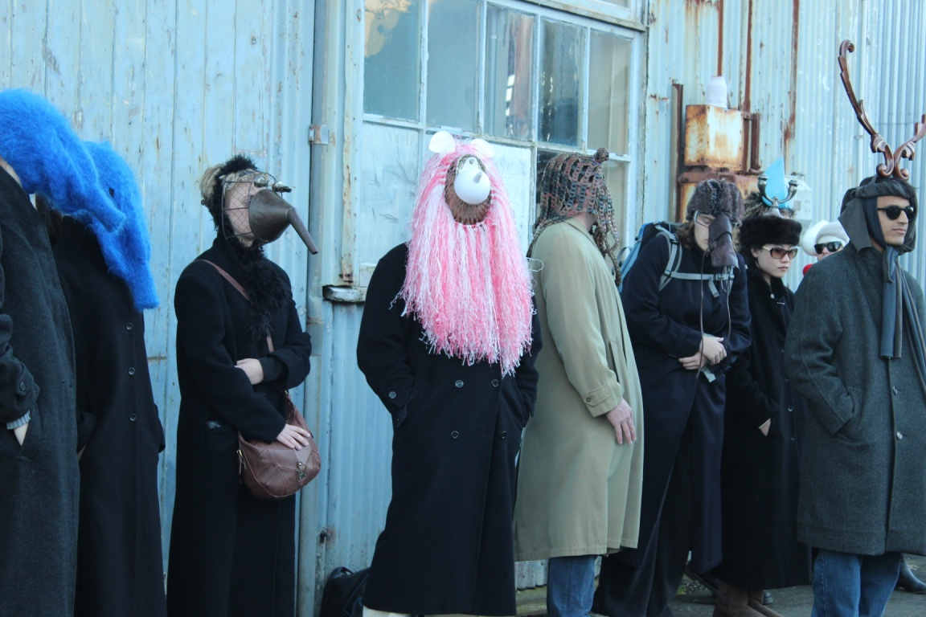
Lyndal Jones, Rehearsing Catastrophe: The Ark in Sydney. Performance: Waiting in Line for Noah’s Ark, Cockatoo Island, Sydney, 2012
- The Brush-work(笔，bi) “moves according to rules, but it enjoys freedom, too. Without hesitation, it is a continuous movement, a flight with no stops in the mid”( 虽依法则，运转变通，不质不形，如飞如动). It is gestural based and limited by natural human limitation and material limitation, but it also has a life borrowed from the movement of human being. It is the most obvious character of Chinese art, benefiting from the tool of the Chinese brush. Yet, it is not restricted to the tool. An artist can easily create his own brush-work with any kind of tool after enough practice as long as he/she abides with the above four essentials.
In Susan Stamp’s drawing workshop “Gesture as Movement and Narrative”, I am excited to see how my Chinese students made obvious achievement on figure drawing within two days, although they had lots of training on that in China. Her attempts to “to explore the relation between figure drawing with moving image, as a gesture of a moving line and gesture as a narrative of action” has its resonance in ancient Chinese tradition. With the help of digital camera, the quick drawing of figure was animated, and provides a more direct insight into the understanding of the relationship between the “movement” of the drawer and the model, and leads to more effective expression. That was a good experiment to explore the potential of traditional drawing class in modern context of digital technology.
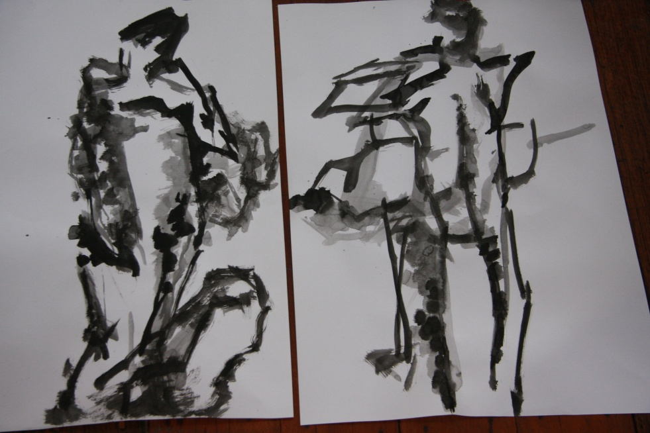
Feng Yuting, Ink on Paper, at Susan Stamp’s drawing workshop “Gesture as Movement and Narrative”, 2012
- The Ink–work(墨, Mo) “gives variations in shading thus forming a natural pattern that does not seem to be made by the painter”( 高低晕淡，品物浅深，文采自然，似非因笔). This is to explore the potential of the media. When ink is applied by Chinese brush on rice paper, there could be surprising effects unexpected because of the water functioning, which can be beautiful textures. However, the ink-work does not have independent aesthetic value. That is to say, if the brush-work of an art work is not good, the ink-work will not be valued no matter how creative and expressive it is. “Ink-work” had been contempt by the orthodox school, although the technique could be dated back to as early as Tang dynasty at the beginning of Chinese landscape painting. Earliest artists such as Wang Mo (王墨), literally Ink Wang, were remarked as “unworthy of learning” (不堪仿效), “though extraordinary” (皆为奇异也。) This is still a bottom-line of the Chinese painting, which emphasize on the bodily involvement of the artist, rather than formal beauty, and is strongly drawing centered in the art activity. Without the brushwork, the art activity of the ink-work is no longer画 (hua), though may still fit into the Western definition of painting. Without brushwork, and the art process is no longer drawing and loses its signification as 写(xie), the writing, so it is not acceptable according to Chinese aesthetics. This may be the conservative part of the “six essentials”, but, I believe, a reasonably conservative part if we value drawing seriously.

The “Six Essentials” have since then become the guiding line of Chinese painters for over 1000 years, and I think it is still valid in our discussion about learning and evaluating drawing in contemporary context. I divide the “Six Essentials” into three groups according to its significance in art teaching and evaluation.
气(qi) | Energy Flow | The basic.  They can be learnt but can hardly be taught.
韵(yun) | Suggestion of high morality through harmony
思(si) | Meditation | The creative.  They should be the major part of school teaching.
景(jing) | The imaging
笔(bi) | The brush-work | The skill  They can be taught, but can be easily misled, so better for the most part be self-taught.
墨(mo) | The ink-work

The first two essentials are things that can be learnt from masterly examples but can hardly be taught. Teaching without democratic attitude could be harmful rather than supportive because the two rely on improvisation and spontaneity of the practiser, and are fundamentally against any ideological institutionalization.
The second two essentials, I believe, are the major part of art teaching that should be emphasized in art schools. They are safe and interesting to teach, and relatively the easier way to open up students’ mind to be more creative.
The last two essentials are the things that should be taught very cautiously, because they can easily become crafty. Among the six essentials, the last two depend on the mastery of the above four essentials. That is why they were listed at the bottom by Jing Hao.
However, pitifully, we have lost the tradition and taught art in the reversed order in China, because the last two essentials, especially the “brush-work”, have been categorized orderly, such as in the “ Muster Seeds Manual Book of Painting” (《芥子园画传》, first published in 1679) , so made “visible”, while the rest four remained “invisible” in their complexity and gradually become mystery. Yet, according to Jing Hao, there exists “invisible faults”, and with only the training of the “visible” skills does not make a good artist.
As for the evaluation of an art work, few artworks are good in all the “six essentials”, but the first two essentials are basic to all good art works, so should be the basic criteria in the evaluation. Accordingly, Jing Hao listed four ranks of evaluation:(spontaneously) magical (神, Shen); (naturally) subtle (妙, miao); surprising (奇, qi); (deceitfully) artful (巧, qiao), but they should be the topic of another paper.
The attempt to build up a dialogue between Western contemporary and Chinese tradition in art theory and practice is a very hard, but very rewarding job, for it brings together the best parts of human wisdom to construct understanding between the East and the West to inspire creativity on both parties. I would like to attach to this article my translation “Story of Learning Brushwork” and hope it would interest more people.

The paper was written for a symposium presentation at National Art School, Sydney, Australia on July 13, 2012, as an activity of the General Assembly, AIAS 2012, which includes four week-long workshops, and other symposium presentations on the topic of “Re: Imagine. Drawing in Dialogue - Narrative, Interpretation and Storytelling”.
For example in the earliest collection of Chinese folk lore during Confucian’s era, “I drove out for fun to release my worries ”(“驾言出游，以写我忧”,《诗经·邶风》） “I feel released now that I saw my lover” (既见君子，我心写兮，《诗·小雅》)
The four workshops are Briony Barr’s “Drawing on Complexity”, Locust Jones’ “The Big Picture”, Leila Sujir & David Seitz’s “Learning to Fly: An Introduction to S3D Drawing with Sandde” and Susan Stamp’s “Gesture as Movement and Narrative”.
In Chinese, 油画（oil painting）, 水彩画（water-colour）are each a kind of painting, while 素描(detailed drawing), 写生(life drawing), 白描(contour drawing), 速写(sketch) are each a kind of drawing.
https://blogs.monash.edu/facultygallery/?page_id=435
http://www.sandde.com/publicpages/whatIs/draw
张彦远《历代名画记》: 不见笔踪，故不为之画。如山水家有泼墨，亦不为之画，不堪仿效
朱景玄《唐朝名画录》

